**Data Resource Profiles**

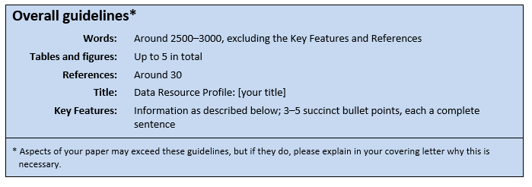

**Purpose**

* To make the research community aware of the existence of data resources across the world.
* To provide enough information to enable researchers to understand the scope of the data resource and how to access and make best use of the data.

Note that:

* Submissions for this category include large sets of data from a defined population that could be used for epidemiological research, are available to bona fide researchers and meet the criteria below.
* Preference will be given to datasets that we believe would be of interest to our readership.
* Data collected at global, regional, national or sub-national level may come from cross-sectional surveys, large randomized or quasi-randomized evaluation studies, or bio-resources. Examples include the [European Union Statistics on Income and Living Conditions](https://ec.europa.eu/eurostat/web/income-and-living-conditions) and the [Human Mortality Database](https://www.mortality.org/).
* This category may include cohorts and data resources that do not meet our criteria for Cohort Profiles.

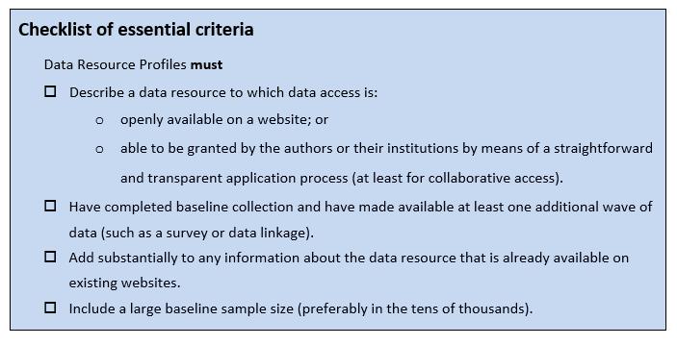

Data Resource Profiles will be published online only. They will still be assigned to an *IJE*issue and listed as ePages in the issue’s Table of Contents.

**Format**

Please refer also to the general [Manuscript Preparation](https://academic.oup.com/ije/pages/General_Instructions#Manuscript%20preparation)instructions.

*Title*: Begin with ‘Data Resource Profile:’ followed by your title (which is usually the name of the database) and then any acronym in parentheses.

*Author List*: (see [General instructions](https://academic.oup.com/ije/pages/General_Instructions#General%20instructions)).

*Note*: Data Resource Profiles do not require an Abstract. Please enter the ‘Key Features’ (see below) into the Abstract field in the ScholarOne website during submission, and select Not Applicable when asked about Key Messages.

**Data Resource Profile sub-headings**

Data Resource Profiles must use the following sub-headings and address the criteria described under each sub-heading (Data Resource Profiles that fail to meet these criteria will not be published):

**Key Features**

Key Features about the Data Resource Profile should be provided as bullet points of no more than 200 words in total. Points should be written as complete sentences that cover the following information:

* why the dataset was established and unique feature(s);
* location, year(s) of baseline data collection, number of participants at baseline, the composition of the study population including age range;
* frequency of follow-up, response rates if repeat cross-sectional surveys, a brief description of any data linkage, the number of participants currently in the dataset;
* main categories of data collected; and
* collaboration and data access.

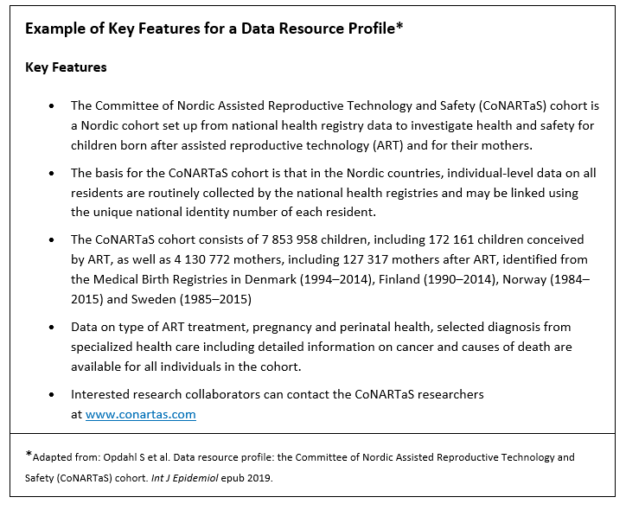

**Data resource basics**

* Provide the rationale for setting up the dataset (including the original research questions that it was set up to address), when it was established, where it is located and how it is funded.
* Define the area covered by the data resource and describe the units, groups and individuals from whom data were collected.
* If data from repeat surveys are available, dates and numbers surveyed, response rates and representativeness should be provided for each repeat survey. This information can be presented in tabular form.
* Provide a brief description of any linkages to other datasets (more detail can be provided in the next section).
* Indicate how long this data resource will be followed up and funded. We prefer data resources that will be followed up for at least 10 years.
* Provide details of ethical clearance (if appropriate) and funding sources.

**Data collected**

This section should describe, in detail:

* any linkages to morbidity, mortality and other routine data sources, including whether the data have been harmonised;
* measures to ensure data quality and anonymisation techniques.

Include brief details of:

* dataset production, including source data, sampling strategy, software and hardware, if appropriate;
* data type (e.g. secondary data) and survey type (e.g. repeat panel data);

Describe (in tabular form if possible):

* the measures collected at each level, e.g. individual, household, indicating the data collection method (e.g. questionnaire, clinic exam, biospecimen, data linkage),
* the type of data collected (e.g. demographic, anthropometric, genetic, hospital episode), and frequency.

Provide broad categories for the data collected. e.g.:

| **Phase** | **Measurements** |
| --- | --- |
| National cross- sectional survey | Self-reported socio-economic position Self-reported major behavioural risk factors for cardiovascular disease Dietary assessments |
| Death register | Date of death, cause of death |
| Cancer registry | Details of cancer — type/grade |

Provide descriptions of unusual measurements (e.g. specialised scans; unique assays) and/or measurements that have been undertaken in subgroups. Further examples of tables of data collected in Data Resource Profiles may be found in previously published articles here ([Table 3](http://doi.org/10.1093/ije/dyz034)), here ([Box 1](https://doi.org/10.1093/ije/dyw248)) and here ([Table 1](https://doi.org/10.1093/ije/dyy048)).

**Data Resource Use**

This should not be an exhaustive list, but an indicative summary.

Please:

* provide one or two brief illustrative examples of how the data resource can be used, or examples of published work which has used this data resource;
* indicate any ongoing specific data analysis plans here to avoid duplication of effort by others interested in the data resource;
* provide an up-to-date citation list for work published on the data resource.

**Strengths and Weaknesses**

Please cover both strengths and weaknesses.

**Data Resource Access**

Note that at least one of the authors of a Data Resource Profile must be a researcher involved with the data resource presented and be available to readers as a contact person.

Please:

* provide a web address if the data are open access;
* provide links to the relevant documentation such as variable lists or data dictionaries, where available
* describe variable formats and naming conventions;
* indicate any software required to access the data;
* indicate any digital object identifiers of the data resource here;
* indicate where and how to apply for access to the data if permission is required;
* describe opportunities for collaboration if access to the data is more limited; and
* provide the name and contact details of a researcher to whom enquiries can be submitted.

**Ethics approval**

See the general [Manuscript Preparation](https://academic.oup.com/ije/pages/General_Instructions#Manuscript%20preparation) instructions.

**Author contributions**

These are now required. See the general [Manuscript Preparation](https://academic.oup.com/ije/pages/General_Instructions#Manuscript%20preparation) instructions.

**Supplementary data**

If your submission includes these, please add: “Supplementary data are available at IJE online”.

**Funding**

See the general [Manuscript Preparation](https://academic.oup.com/ije/pages/General_Instructions#Manuscript%20preparation) instructions.

**Acknowledgements**

This section is optional. See the general [Manuscript Preparation](https://academic.oup.com/ije/pages/General_Instructions#Manuscript%20preparation) instructions.

**Conflict of interest**

See the general [Manuscript Preparation](https://academic.oup.com/ije/pages/General_Instructions#Manuscript%20preparation) instructions.